Demographic Transition Model

A Demographic transition model is a graphic which show how the population is changing over-time.
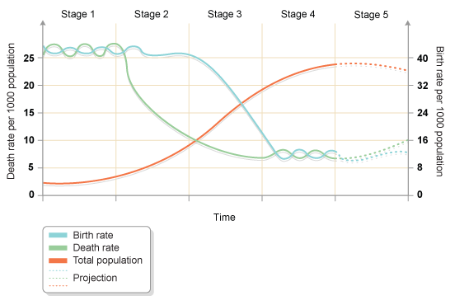www.bbc.co.uk
There is 4 different stages: Pre-modern (1), Urbanizing / Industrializing (2), Mature Industrial (3), Post-Industrial (4).
The fifth stage is just what the scientists predict for the future.

Stage 1: Pre-modern
The birth and death rates are really high. The population is low, and they are having more children to keep the balance between the birth and the death rates, so the population is not changing/growing.

Stage 2: Urbanizing / Industrializing
The death rate decreases a lot, because of the evolution of the healthcare, so less people die and they live longer. The birth rate stayed high, and the population starts to increase.

Stage 3: Mature Industrial
As the death rate is really low and that the population is growing really fast, the people saw that they don’t need any more to have more children, which makes the birth rate going down. A majority of the developing country are in this stage.

Stage 4: Post-Industrial
The birth and death rates are stabilizing in a really low level. The population is “finishing” its evolution. This stage is really balanced, and is the opposite of the first stage. All the developed countries are in this stage.

