Developed and developing country?
A developed country is when the population is “stable” (stage 4, Demographic Transition Model) and where there is no economy problems. There are good resources, so people are living longer and are also having less children.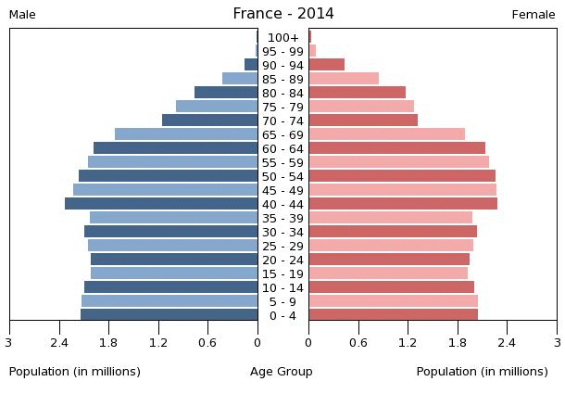
A developing country is when the population is changing (stage 3, Demographic Transition Model) and when the economy is really low. As the population is growing, they need more money to feed everyone or having a better healthcare, but they don’t have enough money to pay all the resources that they need so the people are not living that long.